Middle Level Control



Figure. Working circuit model

The electric-hydraulic servo system is

Define the load pressure as

Where

It is observed that the flow rates satisfy the following relationships

Where

Define the state as .

The system can be expressed in the following state space representation:

Where

Lift plant and tilt plant are both the system described above.

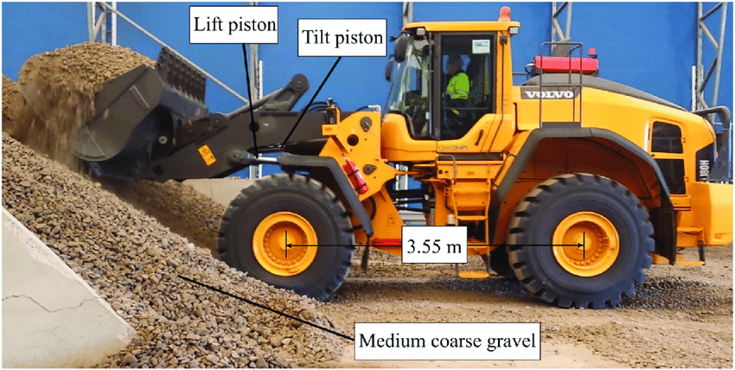

From lift and tilt position, we can get bucket trajectory.

The force acting on the bucket tip is estimated using a model (fundamental earth moving equation) given the bucket tip trajectory. [1]

Then the load force on lift and tilt piston can be obtained through linkage mechanism, which is done by TAMU collaborators.

[1] Force-balancing algorithm to remove the discontinuity in soil force during wheel loader excavation

**Tracking digging trajectory**

The lift load on lift piston and tilt load force on tilt piston are shown below. Uncertainties are added.



Just Feedback controller (FB). In this case, a PI controller is adopted. The block diagram of the control architecture is shown below.

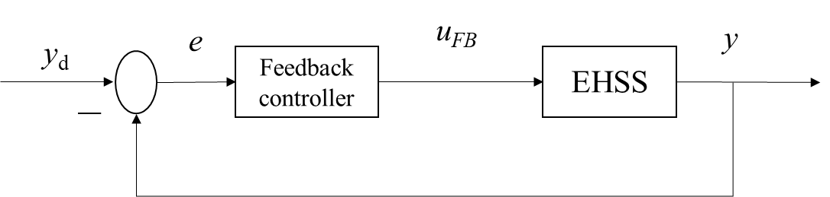

Figure 2. Control architecture

The tracking for lift and tilt piston positions are shown below.





The control inputs for lift and tilt function are shown below.



Through linkage, the lift and tilt piston position can be converted to the bucket trajectory, which is shown below. One is reference, the other is the simulated result.

